Eduardo Cabrera-Lopez

Professor Tawanda Chiyangwa

ITAI 3377

August 2, 2025

Smart Traffic – AI Traffic Optimizer

**1. Project Proposal and Scope**

Traffic jams, longer response times for emergencies, and inconsistent signal control are all problems that urban areas around the world are dealing with. These problems make commuters angry and hurt the environment. To solve these problems, I provide a conceptual architecture for the Smart Traffic Optimizer. This is an autonomous edge-based AI agent that uses generative AI to dynamically manage and improve traffic light patterns at important crossings.

The Smart Traffic Optimizer works in real time by looking at live data from cameras, LIDAR, and induction loops. It will use generative models to predict how traffic might flow and reinforcement learning to make decisions about signals. The system may use these simulations to identify short-term traffic jams and respond to them before they happen. This will help reduce the total wait for all vehicles, improve the timing of green lights, and even give emergency vehicles priority. The goals are to make traffic less congested, use less fuel, produce less pollution, and make the roads safer.

This system is designed to work at the edge, which means that choices are made at junctions instead of relying on a central cloud. This cuts down on lag time and makes sure the system keeps working even when the internet goes down. Also, by using generative AI approaches like diffusion models or GANs, the traffic agent can simulate millions of flow changes before choosing the best course of action. This gives them proactive control instead of reactive control.

**2. System Architecture (in theory)**

The Smart Traffic Optimizer is made up of both hardware and software. The hardware pieces include sensors and edge processors, while the software parts include the AI model, decision logic, and communication protocol. This is how the conceptual data flow is set up:

1. Input Sensors: Traffic cameras take photographs of cars and keep track of how many there are and how they move. LIDAR sensors assess how fast and how far apart cars are. Induction loop sensors in the road can identify whether a car is at a stop sign.
2. Edge Gateway: A Raspberry Pi or NVIDIA Jetson Nano, for example, sends all sensor data to a local edge device that serves as a preprocessing hub.
3. Generative AI Engine: The edge device looks at the data that comes in and feeds it to a small generative model that has been trained to guess what traffic patterns might look like based on what it sees right now.
4. Decision Agent: A reinforcement learning algorithm works with the model to look at the simulations and choose the signal pattern that will keep traffic moving the best for the following 60 to 120 seconds.
5. Signal Execution: The agent sends commands to the traffic light controller, which adjusts the length and order of the lights in real time.
6. Feedback Loop: The agent keeps learning and getting better by looking at the new traffic state after it has acted.

Some examples of communication protocols are:

* MQTT: A lightweight way for sensors to talk to each other.
* HTTPS/TLS: For sending control signals and model updates securely.

Safety measures on the edge:

* Encrypting gadgets to prove their identity
* Control access based on roles
* The device has firewall and anomaly detection modules.

***Diagram description:***  
***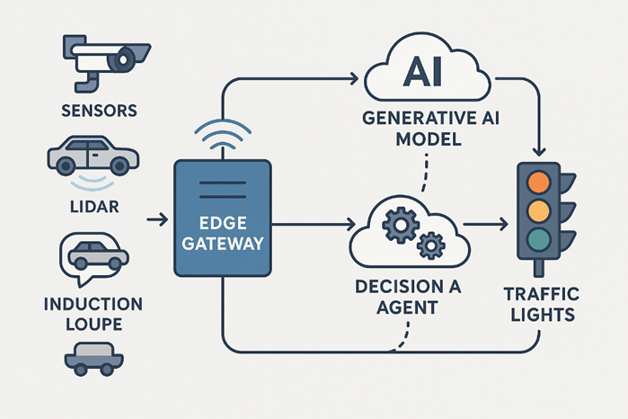*  
Sensors → Edge Gateway → Generative AI Model → Decision Agent → Traffic Lights**

Sensors send data to the Edge Gateway, which sends it to the Generative AI Model. The Decision Agent then sends the data to the traffic lights.

**3. AI Model Development (Idea)**

The Smart Traffic Optimizer is based on a mix of generative modeling and reinforcement learning.

* The Generative Component trains on a variety of urban traffic situations, such as rush hour, accidents, and special events, using fake traffic data. A diffusion model or lightweight GAN can use real-time sensor data to predict how traffic will flow in the near future.
* The Decision-Making Component uses reinforcement learning (RL), which is a good way to make decisions in a row when you don't know what will happen. The RL agent looks at the simulations that were made and picks the traffic signal sequence that lets the most cars through and cuts down on the average wait time for cars.
* Backup: There are rules built in for handling edge cases like power outages, sensor failures, or system reboots.

Tools – Conceptually only mentioned:

* TensorFlow Lite: Good for putting models on small edge devices.
* Edge Impulse: This might be utilized to train classification algorithms ahead of time for finding objects.
* Google Colab: To train and test things before they go live.

This hybrid model strikes a balance between performance and computational economy, making it possible to deploy it even on edge devices with limited resources.

**4. Safety and Moral Issues**

It is very important to make sure that autonomous urban infrastructure is private and equitable. The Smart Traffic Optimizer uses the following security and ethical practices:

* All sensor data sent over the internet is encrypted from end to end using TLS.
* Using public/private key pairs to authenticate devices makes ensuring that only authorized systems may access or change the agent.
* Signing firmware makes guarantee that third-party software injections don't hurt the edge device.
* Local data processing means that no raw video or sensor data is transferred to the cloud, which lowers the risk.

Concerns about ethics and how to deal with them:

* Privacy: On-device algorithms that blur or conceal license plates and faces are used to make camera feeds anonymous.
* Bias: The system is checked for fairness to make sure it doesn't favor traffic from richer areas or punish pedestrians and bikers.
* Transparency: An explainability module will keep track of all decisions made and the reasons for them, so city engineers can look over actions and change them if necessary.
* Edge Autonomy: The system makes decisions on its own, which keeps it from being misused for surveillance or centralized manipulation.

**5. Plan for Putting Things into Action and Testing Them (Theoretical)**

There is no code in this conceptual path, but we can make a realistic plan for testing and deployment in a simulated environment.

Plan for Edge Deployment:

* Use TensorFlow Lite models that have already been trained on Jetson Nano or Raspberry Pi.
* Use Node-RED or SUMO (Simulation of Urban Mobility) to set up three fake intersections.

Testing Situations:

1. Morning Rush Hour Simulation: Measure the timing of signal cycles before and after optimizing the agent.
2. Finding Emergency Vehicles: Pretend that a siren and a vehicle are there and see how quickly the system responds.
3. Road Blockage That Wasn't Expected: Add an anomaly to the simulated data to see how well the agent can adjust.

Metrics for Performance:

* Average delay for each vehicle (in seconds)
* Change in the number of cars that can pass through (cars per minute)
* Delay in signal determination
* CPU/memory use on edge devices
* Time it takes for emergency vehicles to get through

A feedback system would keep track of test results and system choices so that the model may be improved over time.

**6. Challenges, Trade-Offs, and Lessons Learned**

There are a lot of trade-offs to make when designing a traffic optimization system with AI and edge computing:

**Problems**:

* **Latency vs. Complexity**: More powerful AI models can provide better simulations, but they cost a lot of computing power and could delay down choices made in real time.
* **Data Volume**: If not properly preprocessed, real-time visual data from cameras can put a lot of stress on edge processors.
* **Generalization**: Traffic patterns vary greatly from one place to another, therefore models need to be able to change without having to be retrained for each city.
* **Security Risks**: Like any other networked system, weaknesses in the communication stack (like MQTT) could be used to hack it.

**Things to think about**:

* Finding a balance between how well the model works and the limits of the edge device
* Picking between training in the cloud and fine-tuning on the device
* Putting privacy ahead of detailed accuracy from camera feeds

**Lessons Learned**:

* AI solutions that work at the edge need to be light, respect privacy, and be able to handle problems.
* Generative AI adds a proactive layer of intelligence by modeling possibilities instead of just responding to present data.
* Planning the architecture carefully ahead of time lowers technological and ethical concerns later.

**📌 Conclusion**

The Smart Traffic Optimizer is a cutting-edge way to make city transportation more modern by combining generative AI, reinforcement learning, and edge computing in a safe IIoT framework. Traditional traffic systems are not working as well as they used to as cities get more crowded and populations rise. By adding smart agents that can make judgments in real time and on the spot, cities can change their traffic systems from static, rule-based control to adaptive, predictive optimization.

This idea project shows that it's feasible to make a system that works well and is also morally right. The system can simulate traffic circumstances soon because to the use of generative models. This lets it take a proactive approach instead of just reacting to changes in signals. Reinforcement learning makes sure that the agent keeps becoming better at making decisions based on experience, so it can adapt to changing patterns in cities over time.

Edge computing has many benefits, like faster response times, better data privacy (since sensitive information can be processed locally instead of being transferred to centralized servers), and the ability to keep working even if the network goes down. The system design includes security and justice, recognizing that public infrastructure needs to be clear, reliable, and open to all users, including vehicles, pedestrians, bicycles, and emergency responders.

In a bigger sense, this study shows how generative AI and autonomous agents can be useful tools for smart cities in many areas, not just traffic management, but also energy, public safety, and waste reduction. The lessons acquired here—how to balance model complexity with edge limitations, how to plan for ethical considerations, and how to plan for strong testing strategies—can be used in various real-world deployments.

This idea might eventually turn into a pilot program, where AI agents are put in simulated or controlled real-world junctions and then gradually expanded to cover the whole city. Working with civic engineers, transportation planners, and lawmakers would make sure that there is sufficient monitoring, ongoing feedback, and compatibility with current smart infrastructure systems.

The Smart Traffic Optimizer shows that using AI and IIoT concepts in a smart way may make cities smarter, safer, and more sustainable. This gives cities the power to regulate themselves and make life better for everyone on the road.